Patron Record Oddities

Since the upgrade on Feb 17th, 2016, there have been reports of unusual information appearing in some (but not all) patron records. They appear in Modify User only, not in Display User.

For example, in Modify User, fields such as ACTIVEID, PREV_ID, and BIRTHDATE will appear in Extended Info
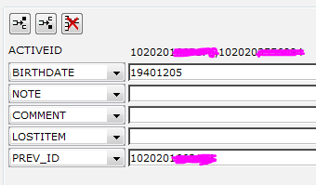

And in the Address tab, these same patrons will show an uneditable field for “County”

DISREGARD ALL THESE FIELDS. They have no meaning.
We believe they are vestigial fields brought over in the first migration from DRA to Sirsi in 2004 since all the users affected have a “Date Created” of 3/12/2004.

The latest upgrade just made them visible. SirsiDynix is aware of the issue and working on a fix for one of the next upgrades.

Most importantly, DO NOT EDIT THE BIRTHDATE FIELD IN EXTENDED INFO
Only edit the Birthdate field in the Demographics tab, as you have done in the past.
